

**Project Report**

**On**

**Tour and Travelling Management System**

**(Information Gathering)**

**COURSE TITLE : Software Engineering Sessional**

**COURSE CODE : CSI 331**

**Submitted by :**

***Black Zombies***

**Name :Aditi Rajbongshi ID : CSE 063 07385**

**Name :Nazmus Sakib ID : CSE 057 06986**

**Name :Farzana Akhter ID :CSE 063 07425**

**Introduction:**

After completing the project objectives ,motives and feasibility part, our next task is to make a report on information gathering. The information we have collected will represent the following objectives.

**Objectives:**

* Construct interview questions for clients.
* Understanding the clients requirements and gather all the information what they actually want.
* Construct questionnaires for users.
* Summarized the survey results.
* Creating the use case diagram.

**For the task of information gathering we have done three methods:**

1.Interviwed three of our classmates as client.

* Interview structure was funnel type.
* 8 open ended questions in beginning.
* 3 close ended question after that.

2.Used Questionnaires to collect survey from user.

* There are 9 questions in the survey and all of them are specific.

**Interview Information:**

As it was difficult to conduct with a software engineers for our interview, it was decided that we would take interview from some of our classmates. They were so helpful in time of our interview. Moreover, they have enough knowledge on tour and travel which helped us to understand the requirement they want as our client.

**Total Interview Procedure:**

**1.Why do you need this new service?**

**Answer:** Nearly everyone goes on a vacation. For this, tour and travel management system would play a vital role. I want to provide such a service where a single person can easily added to many other groups. It will save the customers tour cost if they get together and go to their desired destination. The system also helps to develop tourism with different cultures. So that they enrich the tourists experience.

**2. What problem is this project going to solve ?**

**Answer:** When we make tour we face many kinds of problems such as manage hotel, vehicle, tour guide etc. We want to provide a services that automates the process and perform all operations related to travelling.

**3. What will happen if this project does not go ahead? How it will affect your business?**

**Answer:** I think it will not affect my business in terms of failure. I want to run this system as my side business. Actually, this is an idea of mine which I want to implement as professionally.

**4. What type of works is involved in travel and tourism industry?**

**Answer:** As I told before, All types of travelling operations like hotel management, selection of vehicles, agents, locations etc included medical support, money exchanging.

**5. What challenges are you looking for in this service ?**

**Answer:** We can see there are many number of travel agencies in the country, but we want to provide the premium quality services . Our platform would make tourism management easy by handling agencies requests and providing services for the customers located at different parts of the various cities.

**6. Why do you want to work with us?**

**Answer:** As we hear from many of friends about your company and your reputation of services. That’s why we have come.

**7. What are you hoping will come at this project?**

**Answer:** Actually, the main hope is to contribute in our tourism sector. There are many foreigner who come to see our beloved country. If we provide them a good service they must be give a satisfied rating for tourism to our country. Therefore, we want to represent our country to the world people. Also there must be a hope of earning money.

**8. What concern you most about this project?**

**Answer:** I love to go on a tour when I get time. I have visited many country with foreign travel agencies . But I have faced many difficulties when I go with local agencies. So, personally I feel concern to improve the quality of our country tourism management.

**9. Do you have any budget range?**

**Answer:** yes. For the first develop we want spend maximum 50,000 taka.

**10. How will you measure the success?**

**Answer:** More signups, more people in our mailing lists, customer feedback etc all this are the variable of measuring the success.

**11. If this project could achieve only one goal, what would it be?**

**Answer:** Of course, the goal is to earn money. As I want to implement this system professionally, my first goal would be money.

2. **Questionnaires (Users):**

We have collected the users thought and their need through the questionnaires. We made this questionnaires and share it among a number of people of different profession via social media . We gave much importance to the users need as our main target is to provide best services to them. The questionnaires are given below:

**Investigation:**

* 95.5% people like to go on travel
* 67.3% people are interested in tour packages
* Season Preference : Winter
* Vehicle Preference : Train
* Type of Tour Preference : Relaxing 34.0% , Romantic 32.0%
* Book the trips : By Internet

**Revised Requirement Analysis:**

After performing the interview and information gathering , we have pointed some terms for our requirement analysis. They are given below:

**Functional Requirement:**

* Users should be allowed to claim their travelling expenses related to their official visits.
* System should support both domestic journey and international journey.
* System should capture traveller name or id, destination, time period, purpose and some accounting info as basic data of visit.
* There should be tracking the user who entered the travel data.

**Non Functional Requirement:**

* All the UI should be unique and running both IE and Firefox browsers.
* Supports many languages.
* Reports are exported to different formats.
* Evert caption should self explanation.
* Valid user/ password.

**Summary:**

After gathering the information we have add two changes in our system. They are:

* We will provide medical support in time of travelling.
* We will provide money exchange service so that the user can easily pay their payment during travelling.

**Conclusion:**

At last we can say that, requirement analysis of the system is considered in detail. Identification of the requirement is also discussed. The use of system is to obtain the identified aim and objectives . Moreover, we have managed an total overview of the system from the user and clients. This will make our job more easy and useful.

**Survey Result:**

**1.Count of Occupation**

**2. Count the people who are interested to go for travelling**

**3.Count the people who are interested in tour packages**

**4.Count of consideration before choosing a holiday destination**

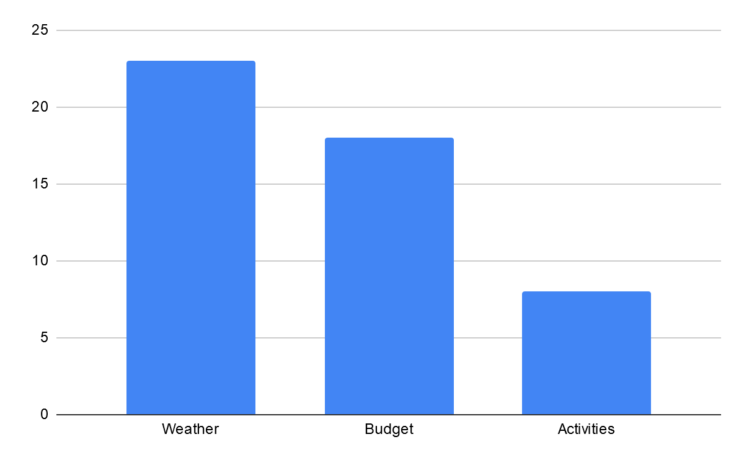

**5.Count the users who want to go on a tour with--**

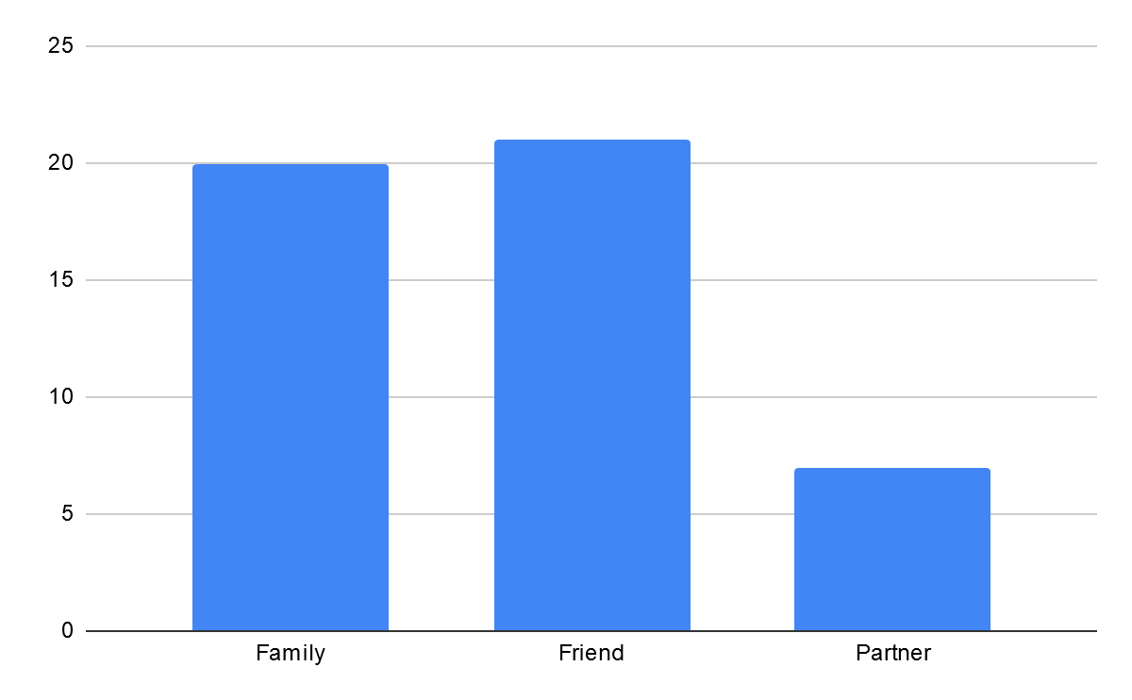**6.Count of the users how they book their trips**

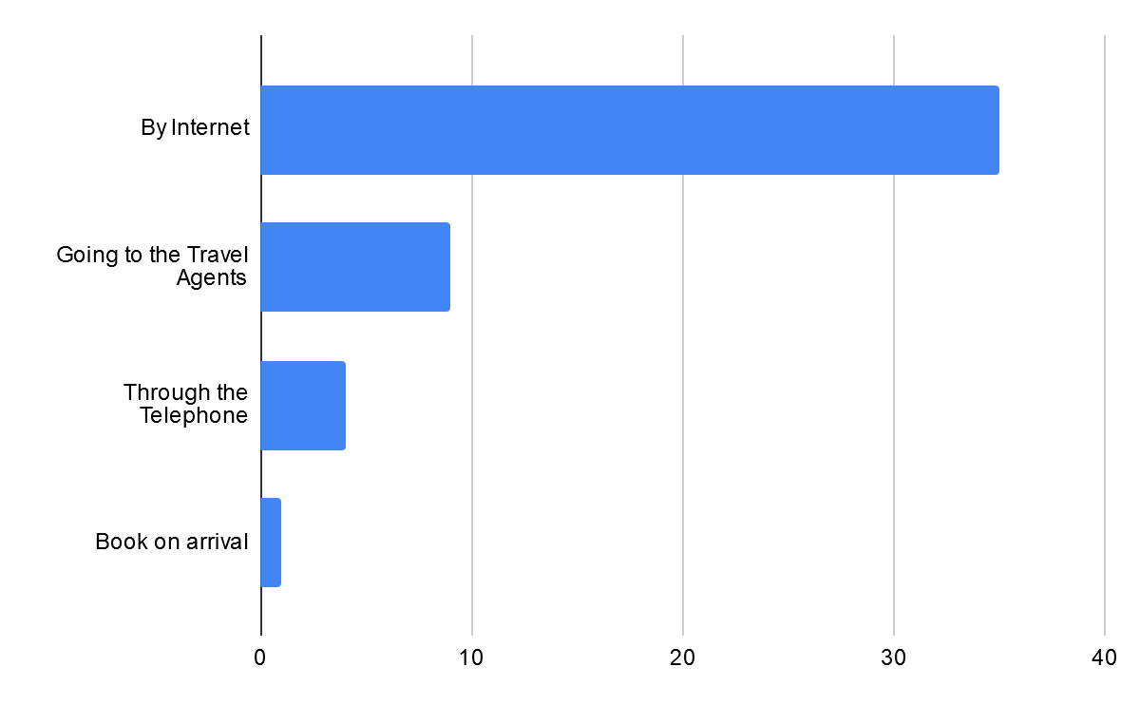

**7. Tour Plan Consideration**

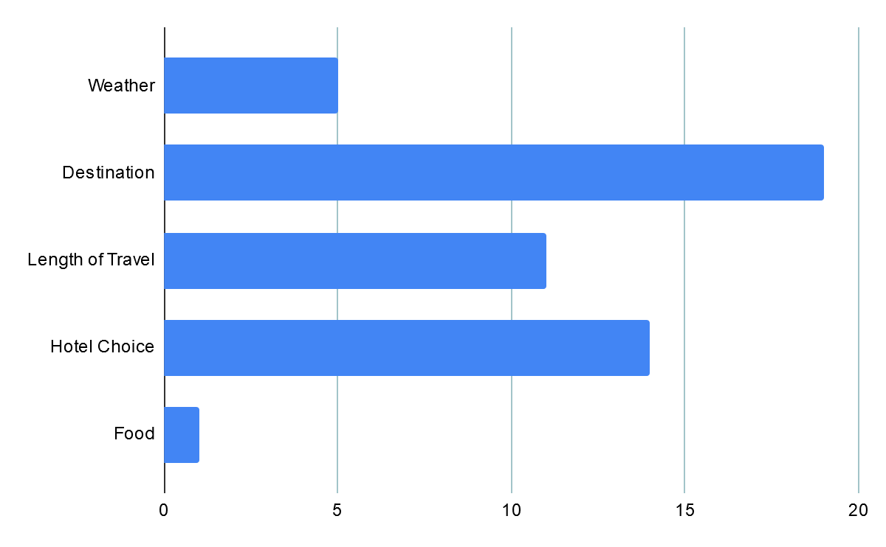

**9.Type of Tour Preference**

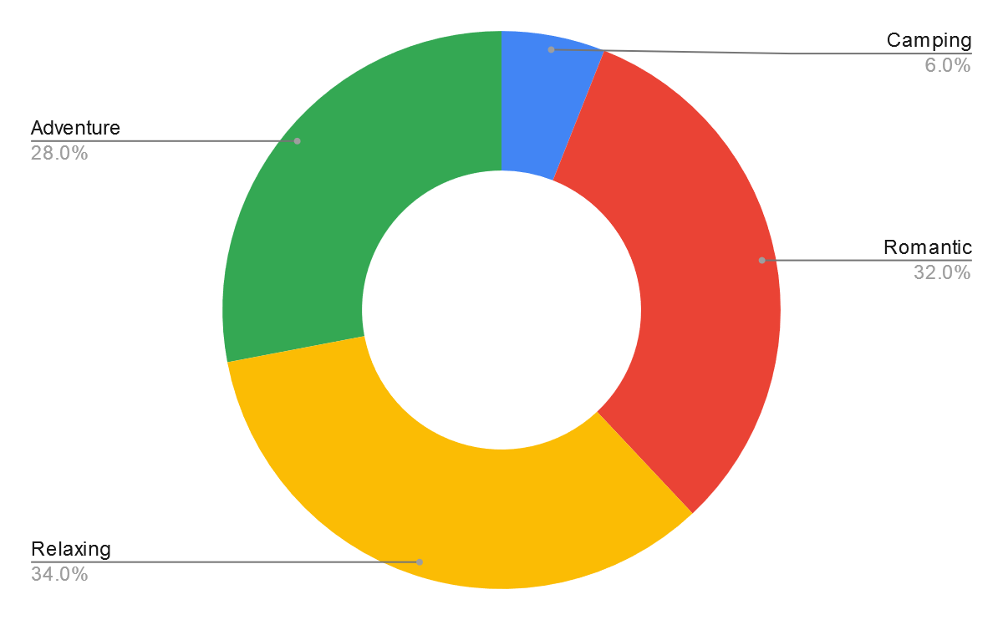

**10. Season Preference**

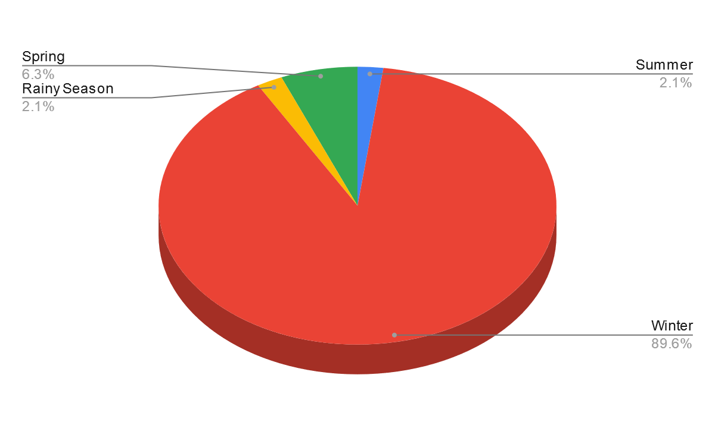

**11.Vehicle Preference**

